Assignment 1

# Introduction

In this Assignment, we were to provide an Implementation of Smart Pointers for Strings in C++. For that purpose, I’ve implemented smart strings here using copied pointers, owned pointers, COW with reference count and COW with reference linking.

# Illustration of concepts

The implementation of Smart string with Copied pointers illustrates the concept that all pointers share common resource, but when one pointer changes the resource, it gets changed for all other pointers too.

The implementation of Smart string with Copied pointers illustrates the concept that when a pointer is copied into another, the ownership is transferred i.e. the original pointer is set to NULL.

The implementation of Smart string with Copied pointers illustrates the concept that when a pointer changes a resource that is being pointed by a set of pointers, the pointers gets the new updated resource hence decreasing the reference count.

While Smart string with COW with reference linking is implemented such that when a pointer changes a resource that is being pointed by a set of pointers, the pointers gets the new updated resource hence decreasing the reference count. It also maintains the record of other pointers pointing to that resource.

# How to run

Compile the provided code with Visual Studio.

# Profiling Data

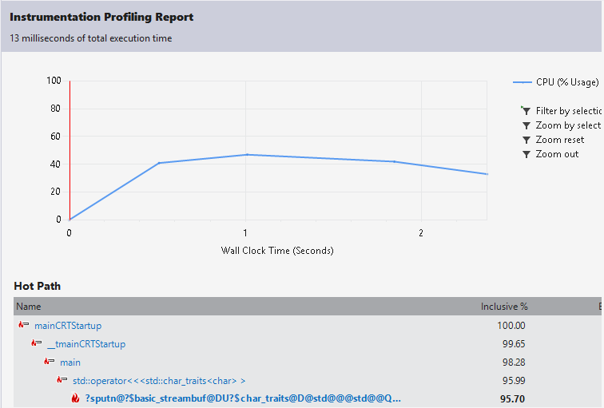



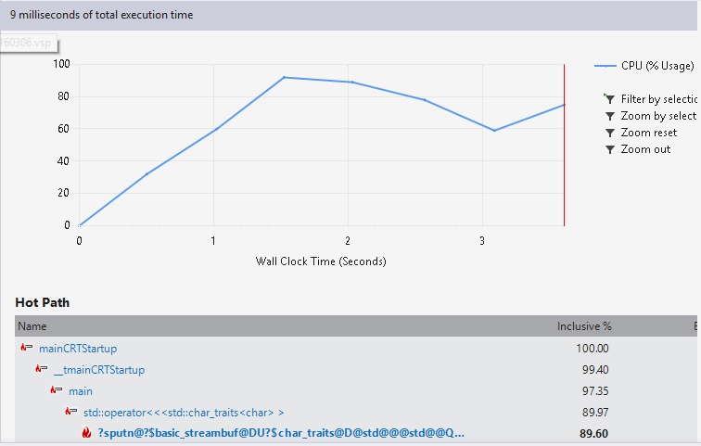



# Github Link